|  | **The University of Texas** **Computer Science** |  |  |
| --- | --- | --- | --- |

**CS 312 Setup Instructions**

These instructions will explain how to setup software and accounts for CS 312. Here is an overview:

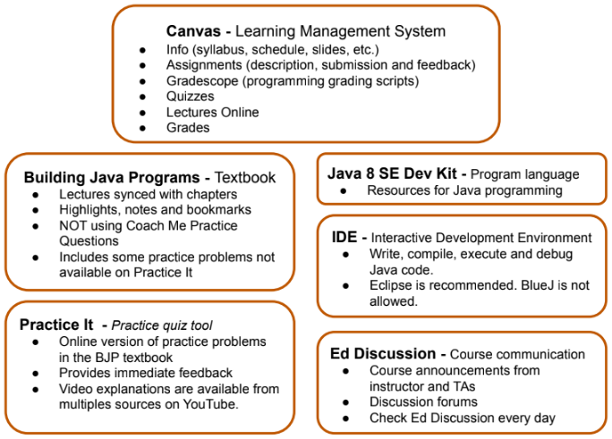

| **#** | **Item** | **Description** |
| --- | --- | --- |
| 1 | Canvas | A Canvas account is created for you when you enroll at UT. You can access it [here](https://utexas.instructure.com/). You can login with your UT EID and password. (There isn’t a separate Canvas login.) For CS 312, you will see these options on the left-side navigation.   * Modules - A weekly and daily outline of course materials. * Assignments - Instructions and submission for Programming Assignments * Gradescope - Programming assignment test scripts and submission * Quizzes - In-class and at-home quizzes * Lectures Online - Recorded lectures * Grades - Your grades for Programming Assignments, Quizzes and Exams * People - The people in your section of the course   Complete these steps in Canvas:   * Choose Gradescope on the left-side navigation. Choose Assignments to verify you can see the 11 programming assignments. * Go to Account, then Edit Profile. Update your name to your preferred name and add your pronouns. Also add a picture. * Choose Name Coach on the left navigation. Follow the instructions to record your name. This will help us learn each other’s names. |
| 2 | Building Java Programs online textbook | The textbook for this class is available through the Longhorn Textbook Access (LTA) program. No setup is required. You can access the book through the “My Textbooks” tab in Canvas. You are automatically opted into the program. (If you want to opt-out, see the professor for instructions.) |
| 3 | Practice It! | Practice It provides an online version of our textbook’s practice problems. These questions are part of Lecture Prep and are essential for preparing for Unit Exams. Most students prefer to do the work in Practice It!, since you can check your answers and feedback is provided.   1. Go to the Practice It home page: <https://practiceit.cs.washington.edu/> and follow the instructions to Create New Account. 2. Login with your new username and password. 3. Click on Building Java Programs, 5th Edition. This is where you will find the same Self-Check Problems and Exercises in the textbook.   NOTE: In the later chapters covered by this course, Practice It is missing many of the problems. In these cases, refer to the online textbook instead. |
| 4 | Ed Discussion | Ed Discussion is our discussion tool. It’s great to have a few TAs and your classmates available to answer questions when you are working on code in your dorm room. From the left navigation in Canvas, choose Ed Discussion. Read the Welcome message and follow the instructions to introduce yourself. |
| 5 | Java | Installing Java is a bit odd. You will run an installer, but you won’t see a new application, like with a typical installation. If you run the installer and don’t get an error message, you are good. Java is there and can be accessed by other programs, such as your IDE. You won’t run it directly.  You will need to use Java V8 for this class. There are newer versions of Java and you might already have one of those installed. But, a few of the assignments required Java V8. (If you already have another version installed, download V8. Then configure your IDE to point to Java V8 for class assignments.)  You will need to determine the type of processor your computer has, to know which installer to use. For MacOS:   * Click the apple logo at the top left of your screen, and click About This Mac. * Look in the information box, it should give details like chip, memory, and serial number.   + If Chip says INTEL, it’s X64   + If Chip says Apple M1 or M2, it’s ARM64.   For a Windows:   * Click Start, type system in the search box, under Control Panel, click System. * Under System, look at the System type entry. It will say either 32-bit Operating System or 64-bit Operating System.   Run the installer for your processor:   * [Mac ARM64 DMG Installer](https://www.oracle.com/java/technologies/javase/javase8u211-later-archive-downloads.html#license-lightbox) * [Mac x64 DMG Installer](https://www.oracle.com/java/technologies/javase/javase8u211-later-archive-downloads.html#license-lightbox) * [Windows x86 Installer (32-bit OS)](https://www.oracle.com/java/technologies/javase/javase8u211-later-archive-downloads.html#license-lightbox) * [Windows x64 Installer (64-bit OS)](https://www.oracle.com/java/technologies/javase/javase8u211-later-archive-downloads.html#license-lightbox) |
| 6 | IDE | You will need an Interactive Development Environment (IDE) to write, compile and run the Java code. The Eclipse IDE is recommended for this course, since class coding and debugging demos will use Eclipse. Run the appropriate Eclipse installer for your machine:   * [Mac x64](https://www.eclipse.org/downloads/download.php?file=/technology/epp/downloads/release/2022-12/R/eclipse-java-2022-12-R-macosx-cocoa-x86_64.dmg) * [Mac ARM64](https://www.eclipse.org/downloads/download.php?file=/technology/epp/downloads/release/2022-12/R/eclipse-java-2022-12-R-macosx-cocoa-aarch64.dmg) * [Windows](https://www.eclipse.org/downloads/download.php?file=/technology/epp/downloads/release/2022-12/R/eclipse-java-2022-12-R-win32-x86_64.zip)   If you have significant experience with another IDE, such as VS Code or IntelliJ, you may continue to use it. (The exception is the BlueJ IDE. Do not use BlueJ for this course.) Know that less support will be available and you may need to solve issues on your own. |
| 7 | IDE Workspace | It is important to create a folder where you will store the projects and files you create in this class. This is called your Working Directory. By default, it is located under the OS user directory. When you run Eclipse the first time, it will ask you to confirm the Working Directory location. Make note of the location so you will be able to find it later. |
| 7 | Google Course Documents | The [Java Class Reference](https://docs.google.com/spreadsheets/d/1Cvj3tVyLiXxX6b4WYkwkxOe0da1xtOmka7ZiDcBxkyM/edit?usp=sharing) and [Java Style Guide](https://docs.google.com/spreadsheets/d/1xbaCCNk75DseOMsYkfHpum0dKlabJXUKP1zp3lfwVvg/edit?usp=sharing) files provide Java guidelines specific to our course. The guidelines are organized by textbook chapter, so you can filter the items to focus only on what you need. **Make a copy of each file to your own Google Drive.** This will give you Edit access, which is required to use the filters. Do not request Edit access to the original files. You will be the owner with Edit access for the copies you create on your Google Drive. Bookmark the files so they are easy to find when you need them.  You will make copies of other Google Docs during the course. Know what your UT Google email is, and be sure you are logged in before you access the doc and make the copy. |