1.4 Procedural Decomposition Practice

Name: _____________________________ EID: _____________

[Practice It 1.4 - 23]

What is the output of the following code?

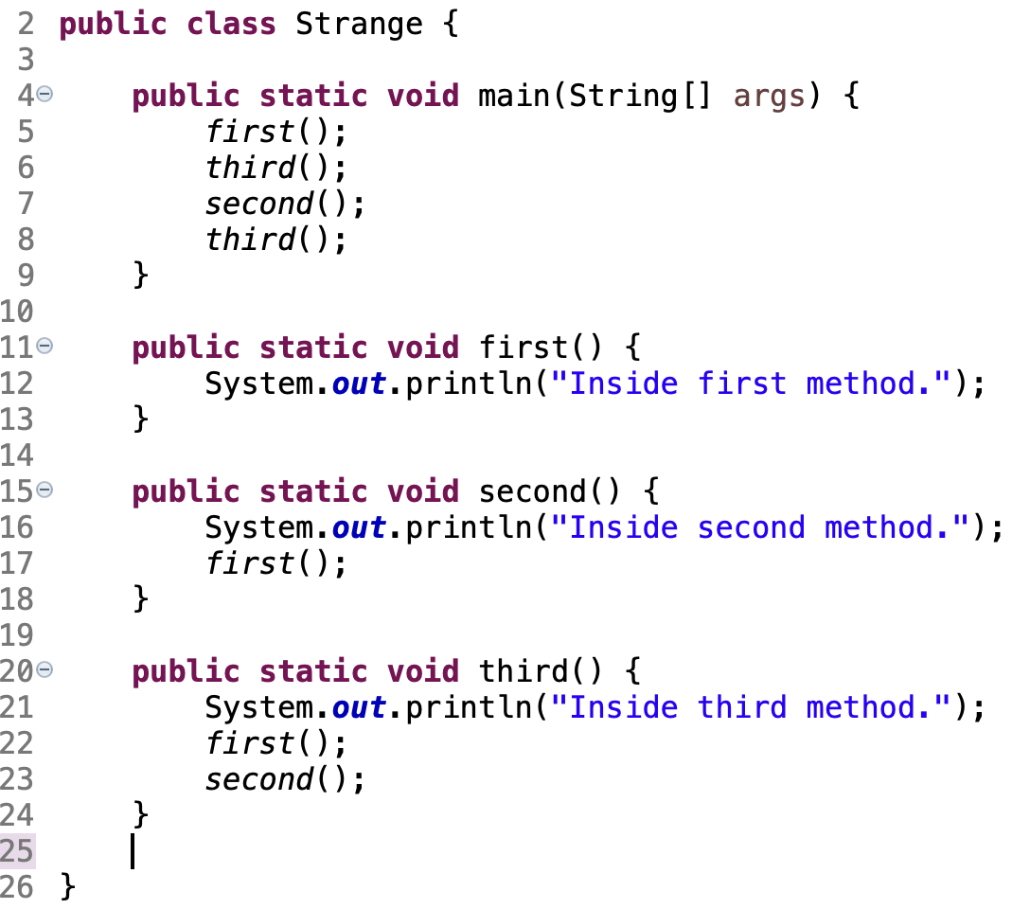

==================== Answers ====================

